## Put market regime as #1step in workflow
When i know what the regime is then I can decide what Universe I want to consider and later if i want to go bearish or bullish and my holding period

## Enhance the Upper section of Direction + horizon with standard setting and option to modify
Bellow is an assessment of the calibration of my filters i want to see all these in the Upper section . find the appropriate way to always have the displayed all the default value and the overwrite value.
If I select the custom option Bamendjou should select what settings are nearer based on holding time) and use them. I would expect only the DTE to be different. That the fixed wired in intraday swing and hold Correct me if I am wrong
After every scan the system should show as log the logs of the last run. It should be persistant when I start direction and horizont i want to see the logs of the last run
When I start the dire
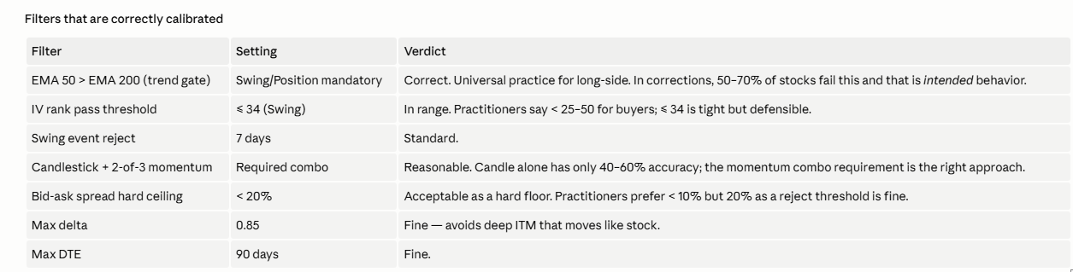
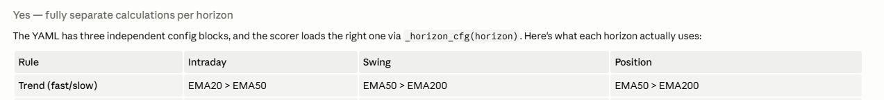
IV Rank show default values add tolerance Field to be maintained in %
RSI floor show default values add tolerance Field to be maintained in %
MACD floor show default values add tolerance Field to be maintained in %
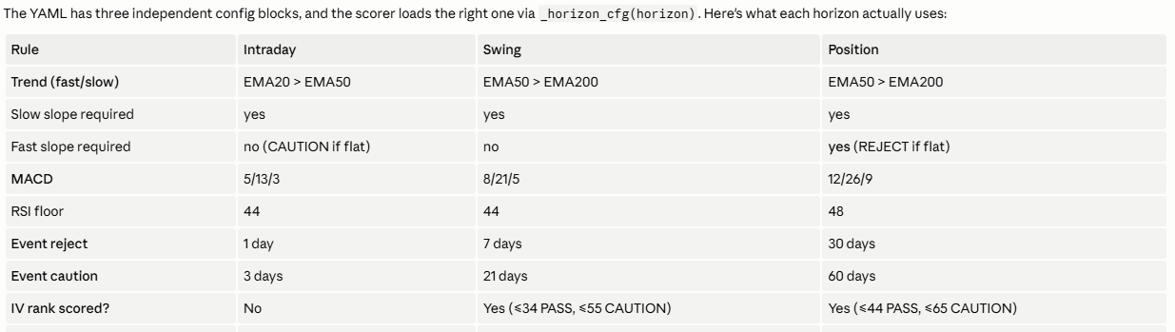
For the following Fields show default and give the possibility of manual overwrite
For Swing and Position I want the option to select SMA50>SMA200
Max Delta
Max candle stick
Bid ask spread
Swing event reject
Event caution can be overwriten
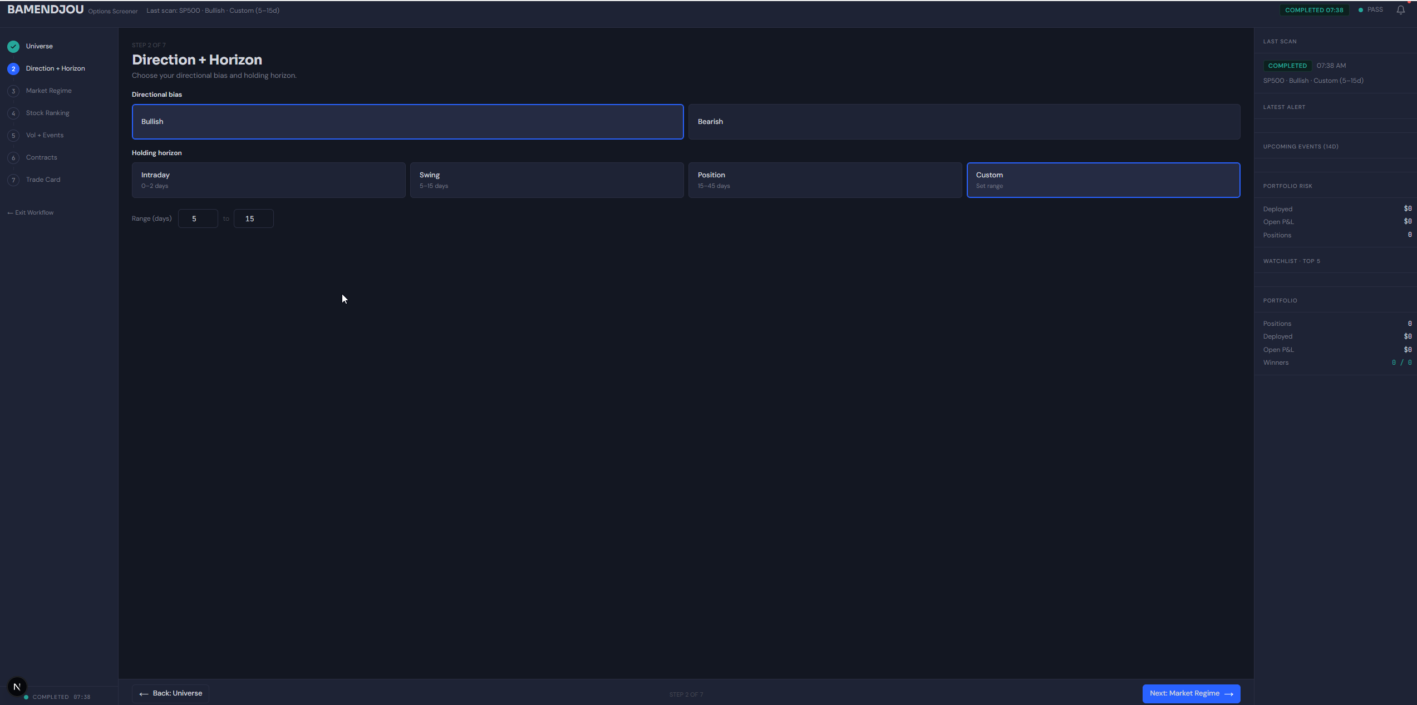

## Add logs in the lower part of the screen after each scan.
At a minimum I want to see the following information. Any other information can be available?
In the lower section I want to see the bread down of the Result of the Scanning bellow minimum useful information feel free to make some proposition of additional info or the was to present the information.
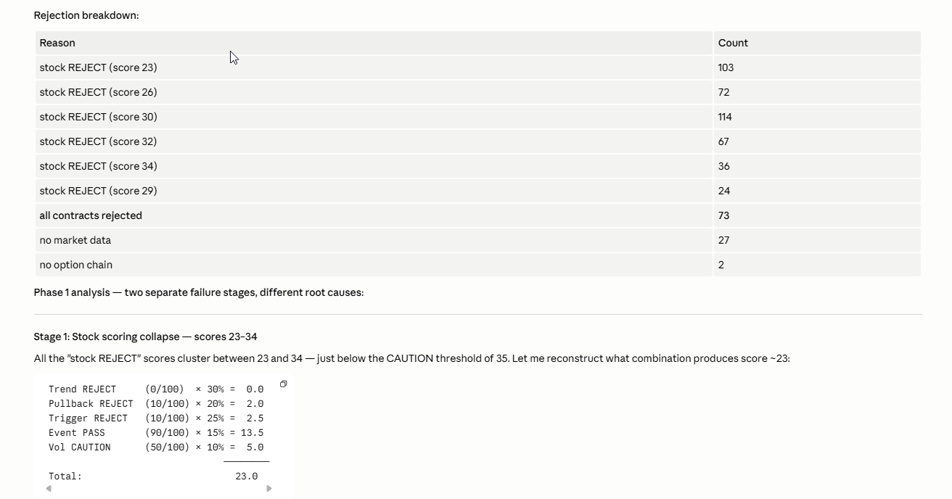

Also added to the logss after each execution: Based on the holding Horizon i want to se what is the best DTE range recommended. And basic explanatory rule for calculation of that DTE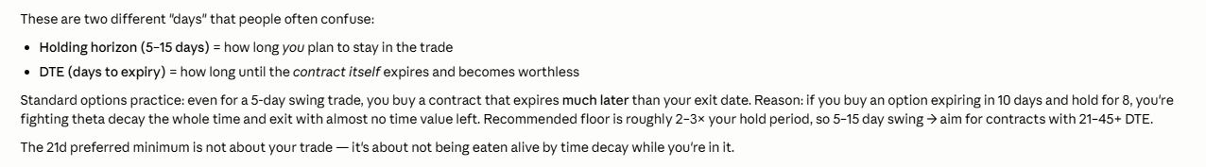

## Additional New card on the Dashboard. General relevant Finacial news. Is it available on tradier? I see it for example on Yahoo finance
In the screenshot bellow you see the section where I want to add the logs
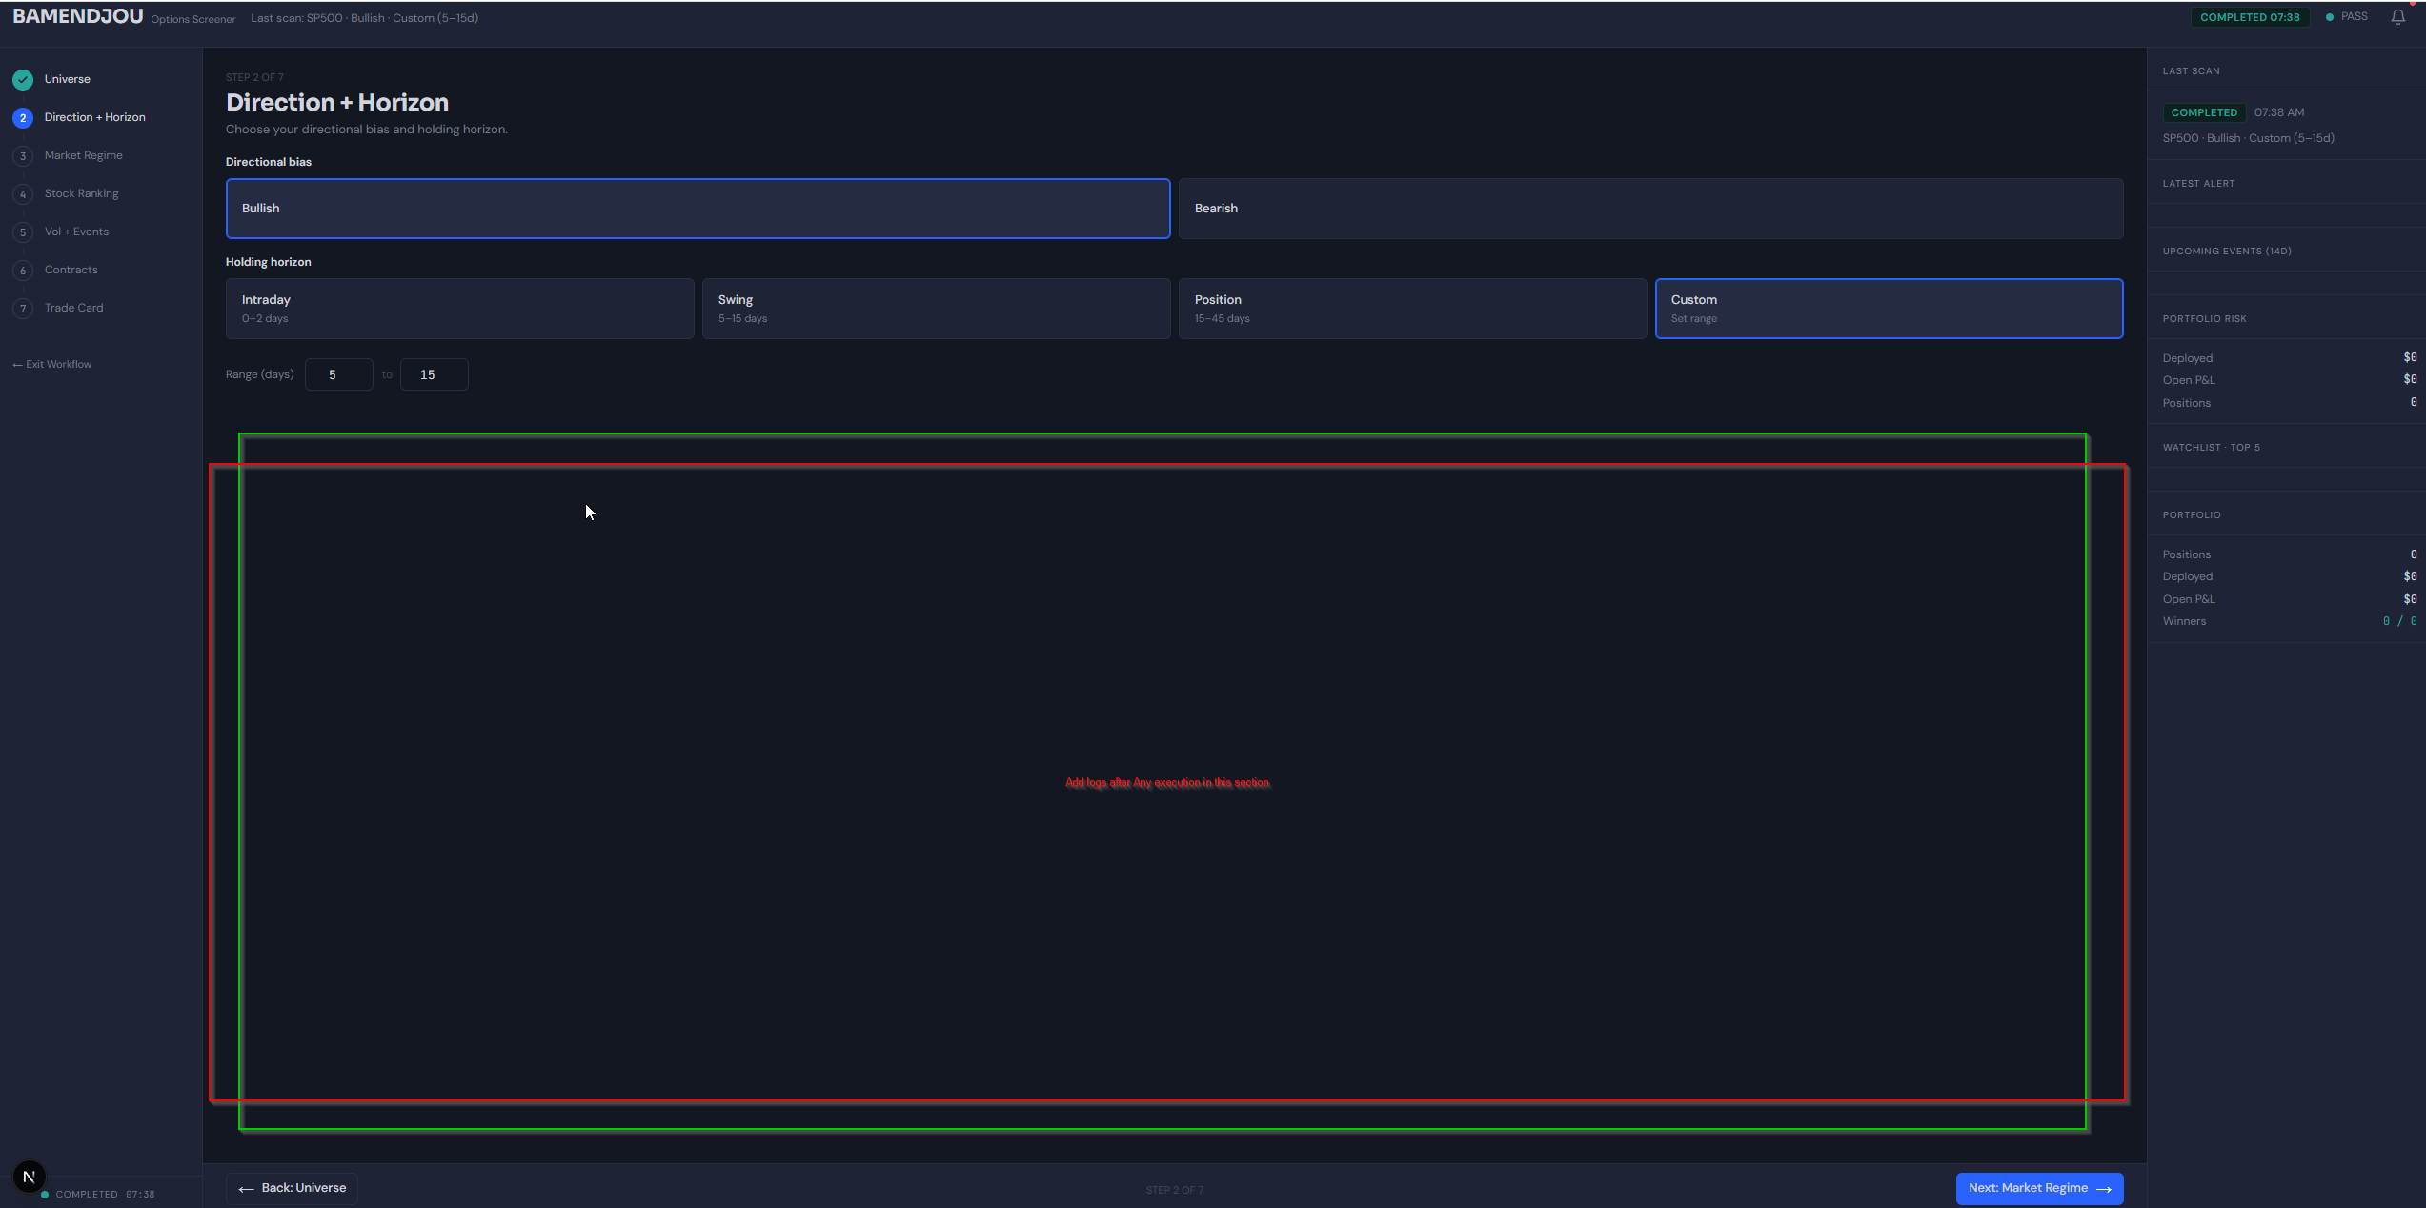

## Bug fixing for Universe selection
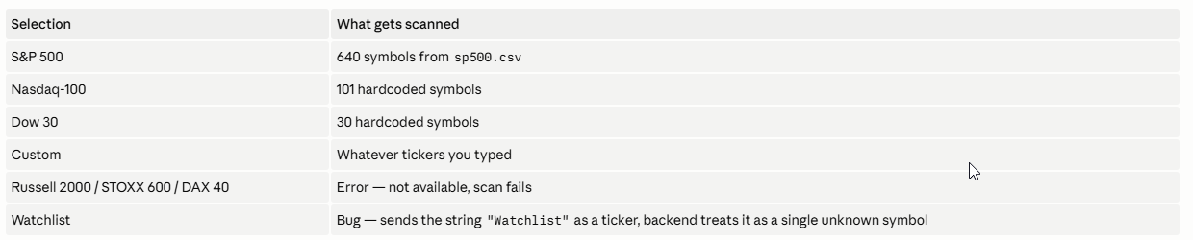
Fix the Bug for selection of watchlist.
Remove Russel 2000 Stoxx and Dax 40
Add SPY

## Propose a solution for dynamic update of universe lists a lot of hard coded stuff that will not get updated
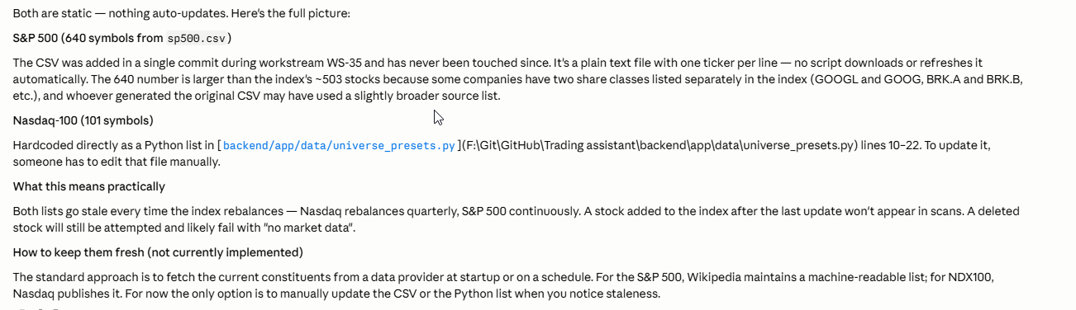
## Add warning if the market regime is not favourable to the trade

